**Quantitative Ecology, Topic 9: Using Secondary Information by Variation Partitioning**

(Based on original notes from Eric Sokol, 3/20/2014; modified by blb 10/11/2015)

I. Starting with constrained ordination (just a bit of review)

II. What is variation partitioning

A. The question it seeks to answer

* partialling out the contributions of two (or more) predictor matrices on a single response matrix
* in community ecology, most often used to partial out the effects of environment and the effects on space on community composition

B. How it generally goes about doing it

* The guts of it are just constrained ordination (RDA, CCA) or distance based constrained ordination (dbRDA)
* Estimates of R2 and partial R2 represent the variation that is explained by different models

C. Typical data used

1. Responses

* Community structure
* Trait structure
* Genetic structure
* And so many other things…

2. Predictors

* Environmental variables
* Treatments from an experiment
* Spatial variables (we’ll talk more about this one specifically)

III. The Method

A. Origins with Borcard et al. 1992, Borcard used CCA in this paper.

* + - Notation for different components
  + [E] = Environment
  + [S] = Spatial
  + ∪ = union (set of all elements in either A or B or both)
  + ∩ = intersection (set of all distinct elements that belong to both sets)
  + [a] = [E|S], pure environmental variation
  + [b] = [E∩S], spatial component of environmental influence
  + [c] = [S|E], pure spatial variaiton
  + [d] = undetermined

**I always like to think of variation partitioning graphically. Here are two examples

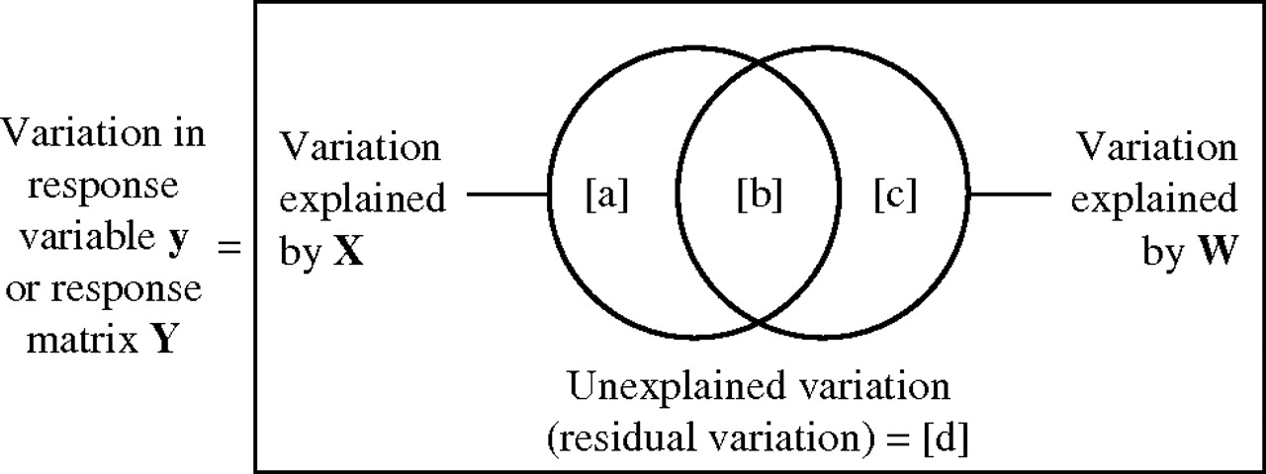

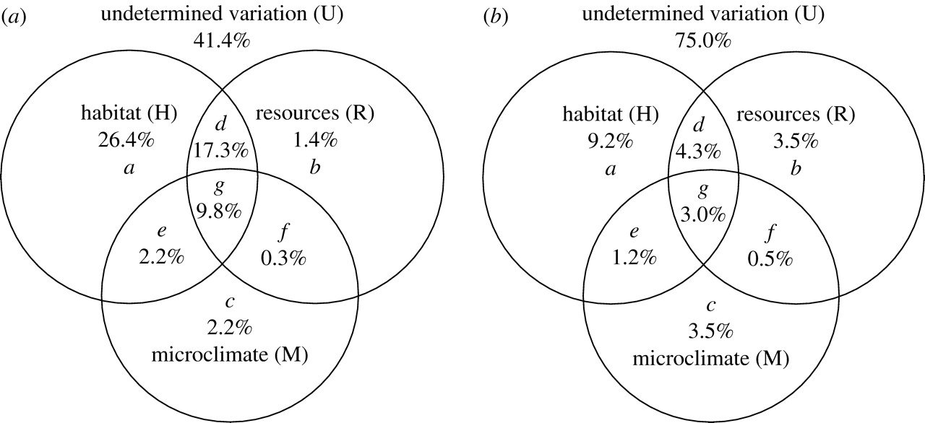

B. How to solve for different components, following Peres-Neto et al. 2006 in Ecology.

1. What each fraction represents

* + - [E] = [a] + [b]
    - [S] = [b] + [c]
    - [E∪S] = [a] + [b] + [c]

2. How to do it

* Use constrained ordination to create models to estimate variation in community composition associated with environment [E], spatial variables [S], and all explanatory variables combined [E∪S], and then solve for [a], [b], [c], and [d]:
  + - * [a] = [E∪S] – [S]
      * [b] = [E] + [S] – [E∪S]
      * [c] = [E∪S] – [E]
      * [d] = 1 – [E∪S]
      * Peres-Neto et al. introduced the idea of adjusted R2 for RDA models.

IV. Spatial Predictors

A. Polynomials

* Borcard used polynomials to model non-linear spatial trends

B. Spatial Weighting Matrix (SWM)

* Product of geographic distance matrix
* Describes connectivity

C. Principal Components of Neighbor Matrices

* Product of a distance matrix and a connectivity matrix

D. Moran’s Eigenvector Maps

* Ordination of spatial variables
* Can reveal patterns that are otherwise not very obvious.

V. Steps in a typical Variation Partitioning (using RDA) based on Sokol VarPart tutorial

1. Hellinger transform community data (Legendre and Gallagher 2001)

* Hellinger transform is simply

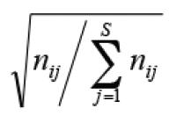

* Gives low weights to variables with low counts and many zeros

1. Transform and scale environmental data if necessary (note: I think RDA automatically scales data in vegan)
2. Convert geographic data into a distance matrix that makes sense, i.e., you want distances in meters, not decimal degrees (the geosphere package is good for this).
3. Calculate “spatial filters” (i.e., spatial variables, e.g., eigenvectors from a PCNM analysis) (Borcard and Legendre 2002, Borcard et al. 2004, Dray et al. 2006, Dray et al. 2012)
4. Use a model selection (Blanchet et al. 2008) technique to decide which spatial variables to include in your variation partitioning analysis
5. Use model selection to decide which environmental variables to include in your variation partitioning analysis
6. Calculate constrained models for [E], [S], and [ES] and the variation explained for each model (the varpart function in vegan does this automatically)

VI. Ecological Interpretations

A. General Interpretation

B. Cotennie et al. 2005 in EcoLetters

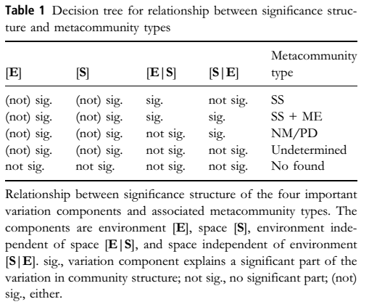

VII. Issues with variation partitioning

A. Gilbert and Bennett 2010

* + - Used simulations
    - Problems with over-fitting spatial variables, under-fitting environmental variables
    - Tests failed to correctly model spatial and environmental components

B. Smith and Lundholm 2010

* + - Used simulations
    - Found spatial and environmental patterns were confounded when dispersal was limited. Modeled processes were not recovered as “expected” when they used variation partitioning

C. Tuomisto et al. 2012

* Scaling mismatch between community turnover and environmental gradients
* Saturation of dissimilarity (things completely turning over more than once along a gradient)

VIII. When does variation partitioning work?

* + Stegen and Hurlbert 2011
    - Used simulations
    - Simulated patterns were not monotonic, but overall, variation partitioning results made sense
  + Diniz-Filho et al. 2012
    - Combined an analysis of spatial autocorrelation with variation partitioning and were able to better identify spatial variation that was linked to dispersal limitation.
  + Review by Borcard et al. 2012 in EcoMonographs explains what you can and cannot do with variation partitioning.
  + Brown, Sokol, Tornwall, Skelton (Brown et al. 2017) talk about best practical uses of variation partitioning in addressing metacommunity theory

**Citations**

Blanchet, F. G., P. Legendre, and D. Borcard. 2008. Forward selection of explanatory variables. Ecology 89:2623–2632.

Borcard, D., and P. Legendre. 2002. All-scale spatial analysis of ecological data by means of principal coordinates of neighbour matrices. Ecological Modelling 153:51–68.

Borcard, D., P. Legendre, C. Avois-Jacquet, and H. Tuomisto. 2004. Dissecting the spatial structure of ecological data at multiple scales. Ecology 85:1826–1832.

Borcard, D., P. Legendre, and P. Drapeau. 1992. Partialling out the spatial component of ecological variation. Ecology 73:1045–1055.

Brown BL, Sokol ER, Skelton J, Tornwall B (2017) Making sense of metacommunities: dispelling the mythology of a metacommunity typology. Oecologia 183:643-652. doi: 10.1007/s00442-016-3792-1

Cottenie, K. 2005. Integrating environmental and spatial processes in ecological community dynamics. Ecology Letters 8:1175–1182.

Diniz-Filho, J. A. F., T. Siqueira, A. A. Padial, T. F. Rangel, V. L. Landeiro, and L. M. Bini. 2012. Spatial autocorrelation analysis allows disentangling the balance between neutral and niche processes in metacommunities. Oikos 121:201–210.

Dray, S., P. Legendre, and P. R. Peres-Neto. 2006. Spatial modelling: a comprehensive framework for principal coordinate analysis of neighbour matrices (PCNM). Ecological Modelling 196:483–493.

Dray, S., R. Pélissier, P. Couteron, M.-J. Fortin, P. Legendre, P. R. Peres-Neto, E. Bellier, R. Bivand, F. G. Blanchet, M. De Cáceres, A.-B. Dufour, E. Heegaard, T. Jombart, F. Munoz, J. Oksanen, J. Thioulouse, and H. H. Wagner. 2012. Community ecology in the age of multivariate multiscale spatial analysis. Ecological Monographs 82:257–275.

Dray, S., S. Saïd, and F. Débias. 2008. Spatial ordination of vegetation data using a generalization of Wartenberg’s multivariate spatial correlation. Journal of Vegetation Science 19:45–56.

Gilbert, B., and J. R. Bennett. 2010. Partitioning variation in ecological communities: do the numbers add up? Journal of Applied Ecology 47:1071–1082.

Heino, J., M. Grönroos, J. Soininen, R. Virtanen, and T. Muotka. 2012. Context dependency and metacommunity structuring in boreal headwater streams. Oikos 121:537–544.

Legendre, P., and M. J. Anderson. 1999. Distance-based redundancy analysis: Testing multispecies responses in multifactorial ecological experiments. Ecological Monographs 69:1–24.

Legendre, P., D. Borcard, and D. W. Roberts. 2012. Variation partitioning involving orthogonal spatial eigenfunction submodels. Ecology 93:1234–1240.

Legendre, P., and E. D. Gallagher. 2001. Ecologically meaningful transformations for ordination of species data. Oecologia 129:271–280.

Peres-Neto, P. R., P. Legendre, S. Dray, and D. Borcard. 2006. Variation partitioning of species data matrices - estimation and comparison of fractions. Ecology 87:2614–2625.

Smith, T. W., and J. T. Lundholm. 2010. Variation partitioning as a tool to distinguish between niche and neutral processes. Ecography 33:648–655.

Sokol, E. R., J. M. Hoch, E. Gaiser, and J. C. Trexler. 2013. Metacommunity Structure Along Resource and Disturbance Gradients in Everglades Wetlands. Wetlands:1–12.

Stegen, J. C., and A. H. Hurlbert. 2011. Inferring ecological processes from taxonomic, phylogenetic and functional trait beta-diversity. Plos One 6:e20906.

Tuomisto, H., et al. 2012. Modelling niche and neutral dynamics: on the ecological interpretation of variation partitioning results. - Ecography 35: 961-971.